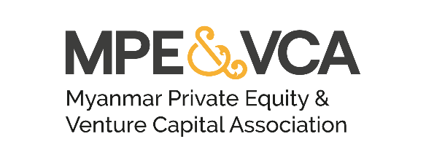
(+95) 09 5010447
info@mpevca.org
www.mpevca.org
No. 3/A Bogyoke Aung San Road #14-00 Junction City Tower
Pabedan Township, Yangon, Myanmar

NOTICE OF THE THIRD ANNUAL GENERAL MEETING
Dear Member,
Notice is given of the Annual General Meeting 2022 of Myanmar Private Equity Venture Capital Association Incorporated (" the Association") to be held in both in-person and online at 3:00 PM MMT (GMT + 6:30) on 13th December 2022.
The Annual General Meeting will receive a report of the Association's activities, in which the Association’s progress and achievements during the past year will be reviewed and initiatives for the rest of 2022 and 2023 will be presented. The accounts for the Myanmar financial year ended 30th September 2021 and 31st March 2022 will be presented at the Annual General Meeting, for members' consideration. Member approval of the Association’s proposed Auditor, U Than Tint from Khin Su Htay & Associates Limited will also be sought.
Eligibility to attend and vote
You are entitled to attend the Annual General Meeting if you are:
- the person your company has nominated as its Investor member of the Association, entitled to represent your company for purposes of voting at general meetings of the Association; or
- one of the persons your company has nominated as an Advisor member or LPs, GPs and Grant Providers, entitled to attend but not vote at general meetings of the Association.

If you are your company's Nominee, you are entitled to vote during the Annual General Meeting. If you are unable to attend, kindly nominate a representative by completing the Proxy Form, which is available on the Association’s website and send it via email to the Secretariat, Trent Eddy at: secretary@mpevca.org and CC: khun@mpevca.org at least 72 hours prior to the Annual General Meeting.
Nominations for Board of Directors
Nominations for the Board of Directors ("Board") are requested. The Board may consist of not more than ten (10) members. Seven of our nine current Directors have indicated their willingness to continue in their roles, with two of our Directors opting to retire. Therefore, the Association will be holding elections for up to three vacancies in the Board of Directors.
Any natural person (Nominee) is eligible for election to the Board, whether or not they belong to a member organisation, provided that: (i) Candidates must be nominated by one other member of the Association (whether Investor, Advisors or LPs and DFIs), and (ii) Investor members make up the majority of the Board of Directors.
New incoming members of the Board will hold office from the close of the Annual General Meeting on 13th December 2022.
Nominations must be submitted in writing to the Secretary of the Association, using the nomination form available on the Association’s website or in the attached file no later than 6:00pm MMT on 5th December 2022.
Nominations shall be submitted to secretary@mpevca.org and CC: khun@mpevca.org.

Forms and Documents
The following forms and documents will be available for download from the Association’s website.
- AGM 2022 Registration Form
- Board of Directors Nomination Form
- Proxy Form

Please do not hesitate to contact us if you have any queries - info@mpevca.org
On behalf of and by order of the Secretary of MPE&VCA, Trent Eddy.

Regards
MPE&VCA

